
Supplemental information:
Figure 1S: Scatter plot of the count of fruit feeding observations two weeks before sample collection and its relationship with temperature. The plot demonstrates a clear positive relationship where fruit consumption increases with rising temperatures.

Figure 2S: Visualization of the eigenvalues of the taxonomic data for each principal component in descending order. Principal components 1 through 3 were used for analysis because they explain >5% of the variation.

Figure 3S: Flowchart outlining the model selection approach for each component of the analysis. Dark grey boxes represent the two data types: 16S rRNA amplicon sequences and shotgun metagenomic sequences. Light grey boxes specify the model formulas applied to each analysis. While the community-level modeling approach used the same model structure for both data types, the models for the temperature and interaction differential abundance analyses differed. Only features for which m_full accounted for more than 50% of the model weight were included in the neopterin–temperature interaction analysis.
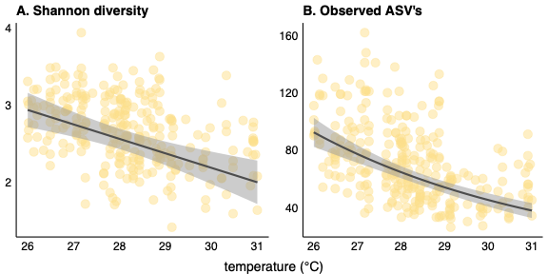

Figure 4S: Plotted model results showing the relationship between taxonomic alpha diversity and temperature. Panel (A) measures alpha diversity using Shannon Index, while panel (B) uses the total number of ASVs. Both metrics demonstrate a reliable decrease in taxonomic alpha diversity as temperature increases.

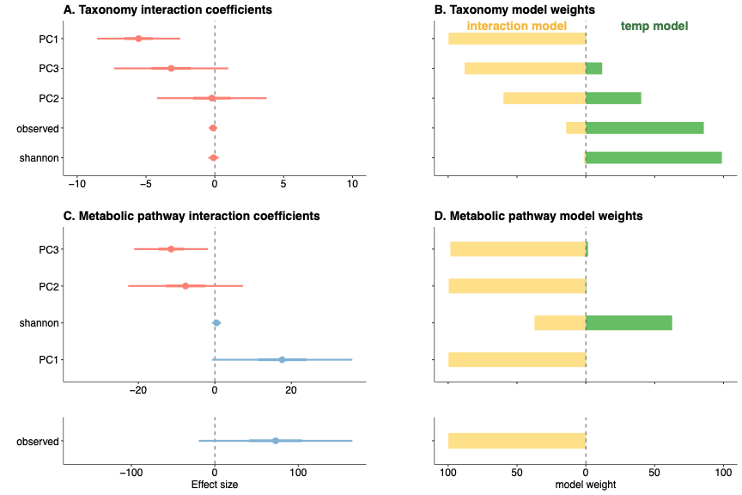
Figure 5S: Model comparison results assessing whether adding an interaction between temperature and neopterin to the temperature model (model with base predictors plus temperature) improves the explanation of community-level taxonomic and metabolic diversity. Panels A and C show the coefficients of the interaction effect for community diversity metrics including beta diversity (measured by principal components 1-3) and alpha diversity (measured by the Shannon Index and the observed number of ASVs or metabolic pathways). The thick bars represent 50% confidence intervals (CI), while the thin bars represent 95% CI. Panels B and D compare the model weights of the temperature model (in green) to the interaction model (in yellow). The weights of the temperature model plus the interaction model equal 100%. The top panels A and B show the results for community-level taxonomic diversity while the bottom panels C and D show the results for metabolic pathway diversity. Results show that the relationship between temperature and beta diversity is associated with neopterin concentration for both taxonomic and metabolic community composition, but the relationship between alpha diversity and temperature is independent of neopterin concentration.

Table 1S: Csv file containing results from the differential abundance analysis of 163 microbial taxa to evaluate their relationship with temperature. The analysis compares a baseline model, m_main, which includes predictors for social group, age, sex, rainfall, and fruit consumption, to a full model, m_full, that includes all the same predictors plus temperature. The column contents are as follows:
- Column 1: Taxon name
- Column 2: Temperature coefficient from the m_full model
- Columns 3-7: Standard error and 50% and 95% confidence intervals for the temperature coefficient
- Columns 8-9: Taxonomic classification
- Column 10: Model weight for the m_full model
- Column 11: Direction of the temperature coefficient (positive or negative)
- Column 12: Classification of the taxon as temperature-sensitive (model weight > 0.5) or neutral (model weight ≤ 0.5)

Table 2S: Csv file containing results from the differential abundance analysis of 383 metabolic pathways to evaluate their relationship with temperature. The analysis compares a baseline model, m_main, which includes predictors for social group, age, sex, rainfall, and fruit consumption, to a full model, m_full, that includes all the same predictors plus temperature. The column contents are as follows:
- Column 1: pathway Metacyc ID
- Column 2: Temperature coefficient from the m_full model
- Columns 3–7: Standard error and 50% and 95% confidence intervals for the temperature coefficient
- Column 8: pathway name
- Column 9: Model weight for the m_full model
- Column 10: Direction of the temperature coefficient (positive or negative)
- Column 12: Classification of the pathway as temperature-sensitive (model weight > 0.5) or neutral (model weight ≤ 0.5)
- Columns 13-14: Functional category assignments for each pathway, or an indication if the pathway was not assigned to any functional category.

Table 3S: Csv file containing the results of the second comparative modeling approach containing 20 taxa whose relationship with temperature is associated with neopterin. The analysis compares a baseline model, m_immune_main, which includes predictors for social group, age, sex, rainfall, and fruit consumption, and temperature to a full model, m_immune_full, that includes all the same predictors plus an interaction effect between neopterin and temperature. The column contents are as follows:
- Column 1: Taxon name
- Column 2: Temperature*neopterin coefficient from the m_immune_full model
- Columns 3-7: Standard error and 50% and 95% confidence intervals for the interaction coefficient
- Columns 8-9: Taxonomic classification
- Column 10: Model weight for the m_immune_full model
- Column 11: Category of the interaction effect, whether the relationship between temperature and abundance becomes more negative (i.e. i.e., the slopes decrease) at higher neopterin concentrations or the relationship between temperature and abundance becomes more positive (i.e. i.e., the slopes increase) at higher neopterin concentrations
Table 4S: Csv file containing the results of the second comparative modeling approach containing 65 metabolic pathways whose relationship with temperature is associated with neopterin. The analysis compares a baseline model, m_immune_main, which includes predictors for social group, age, sex, rainfall, and fruit consumption, and temperature to a full model, m_immune_full, that includes all the same predictors plus an interaction effect between neopterin and temperature. The column contents are as follows:
- Column 1: pathway Metacyc ID
- Column 2: Temperature*neopterin coefficient from the m_immune_full model
- Columns 3-7: Standard error and 50% and 95% confidence intervals for the interaction coefficient
- Columns 8: Pathway name
- Column 9: Model weight for the m_immune_full model
Column 10: Category of the interaction effect, whether the relationship between temperature and abundance becomes more negative (i.e. i.e., the slopes decrease) at higher neopterin concentrations or the relationship between temperature and abundance becomes more positive (i.e. i.e., the slopes increase) at higher neopterin concentrations.

